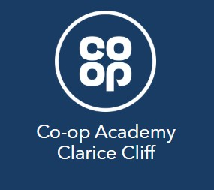
Coop Academy Clarice Cliff School Travel Policy

This school travel policy explains how Coop Academy Clarice Cliff will be encouraging active travel. We will share and discuss the policy with the pupils, staff and parents/carers and re-visit it periodically to ensure its relevance. This policy has been agreed by the Head teacher, senior leadership team and governors.

At Coop Academy Clarice Cliff, we actively encourage our pupils and staff to walk, scoot or cycle to school to:
- Improve both mental and physical health through physical activity
- Promote road safety skills which will help to keep our pupils safe as they travel further afield and more independently
- Help keep our local air clean, and our streets free from congestion and noise pollution
- Reduce the environmental impact of the journey to school
- Establish positive active travel behaviour.

What we do
We will encourage pupils to travel to and from school more safely and actively by:
- Using Modeshift STARS to update and monitor our school travel plan
- Promoting safe and active travel as much as possible by using our noticeboard, displays, newsletter and website at https://www.claricecliff.coopacademies.co.uk/
- Promoting the benefits of active travel
- Celebrating the achievements of those who travel actively to school
- Raising awareness of the air quality benefits of active travel
- Providing cycle and scooter storage on the school site
- Providing cycle and scooter training to all pupils who wish to participate
- Working with outside agencies to deliver interventions and activities that promote active, safe and responsible travel to school.

What we ask of parents.

For the wellbeing of our pupils, we expect parents/carers to:
- Please encourage your child(ren) to walk, scoot or cycle to school whenever possible
- Ensure your child(ren) walk or ride sensibly and safely on the way to and from school, and to push bikes and scooters on school grounds
- Ensure that bicycles and scooters are roadworthy and properly maintained. If in doubt consult a qualified mechanic
- Consider providing your child(ren) with a cycle helmet
- Ensure your child(ren) can be seen by fitting lights to their bike and by supplying them with high-visibility clothing
- Make sure your child(ren) has a lock for their bike or scooter and that they know how to use it
- Ensure you have appropriate insurance cover for your child(ren)’s bicycle or scooter as the school is not liable for any loss or damage to cycles or scooters on the premises or being used on the way to or from school
- If you travel by bus, can you get off the bus at least two stops early and walk the last part of the journey?

Parents and carers are reminded that they are responsible for the safety of their child on the journey to and from school.

What we ask of our pupils
To make active travel a positive experience for everybody concerned, we expect our pupils to:

- Ask your parents if you can walk, scoot or cycle to school
- Behave in a way that shows you and the school in the best light whether walking, scooting, cycling or using public transport
- Ride or walk courteously, sensibly and safely on the way to and from school
- Push bikes and scooters on school grounds
- Check that your bike or scooter is roadworthy and properly maintained
- Consider wearing a cycle helmet
- Make sure you can be seen by using lights in the dark or bad weather and by wearing high-visibility clothing
- Make sure you have a lock for your bike or scooter and that you use it

We understand that sometimes there is no alternative to driving to school.
- Where a car must be used we ask parents to drive only part of the way, and drop their child(ren) off away from the school so that some of the journey can be walked or scooted
  - We have a 5 / 10 minute walk zone we ask parents to park outside of
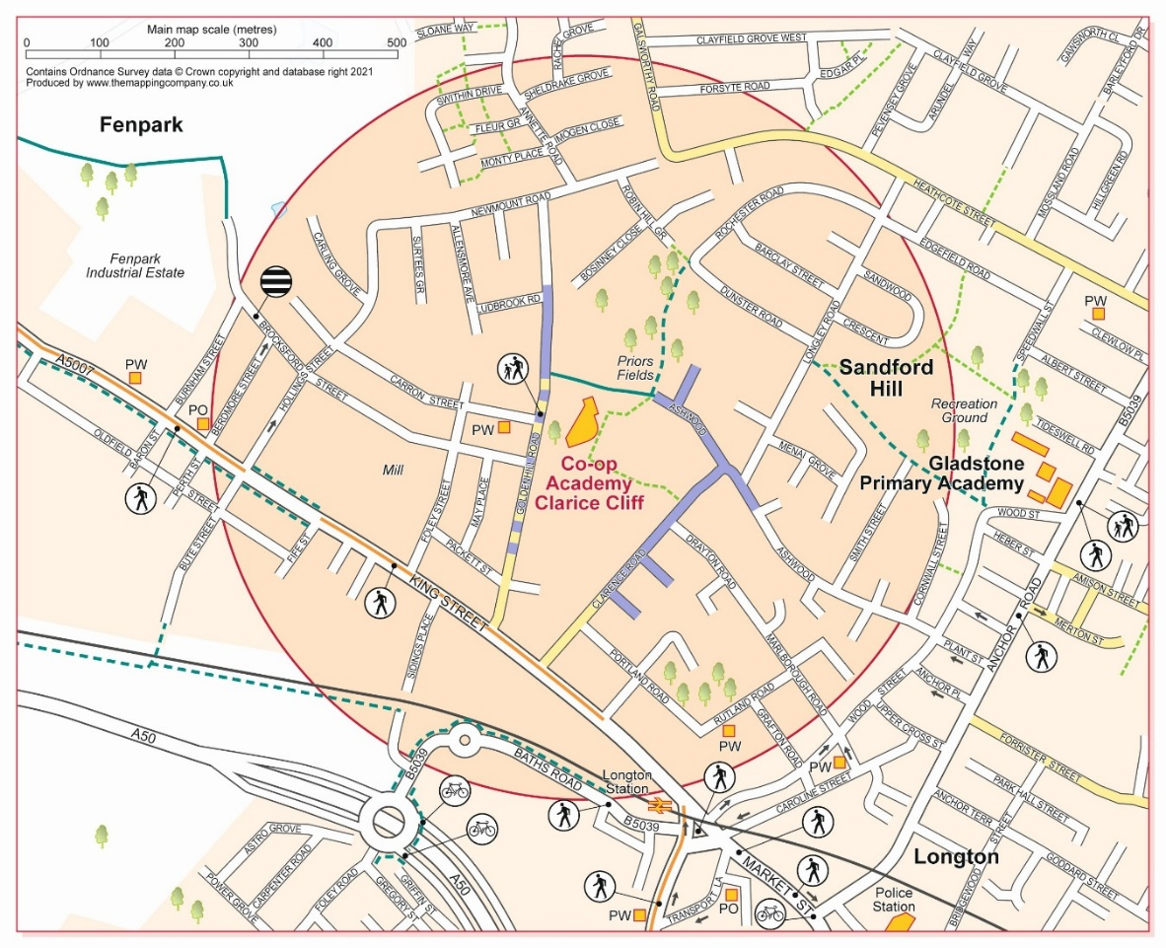

- If you do have to drive your child(ren) and stop in the near vicinity please do so legally, safely and with respect for our neighbours and local residents
  - It is not acceptable to park or wait on double yellow lines, on the school zigzags or across residential driveways for any period of time.

Activities in School

  - Bikeability - Bikeability is the ‘cycling proficiency’ test for the 21st century, designed to give the next generation the skills and confidence to ride their bikes on today’s roads. Each year, pupils in Year 4 & 5 at Coop Academy Clarice Cliff carry out Bikeabilty training both on site as well as in and around the residential roads of Fenton.

  - Pedestrian Training - In Year 4 pedestrian skills are covered in a training programme to help pupils develop their road safety knowledge in fully supervised small groups, pupils explore the roads around the school and discuss safe and unsafe places to cross. Pupils then practise crossing roads safely. They will also discuss how to identify safer crossing points and explore The Highway Code.

  - Outside Agencies - The school works with the Local Authority and the Police to promote active travel and road safety, including running Dr Bike sessions, bike maintenance and safety checks are offered to all children and staff for free.

  - Public Transport - Wherever possible, the school uses public transport for school trips or we walk if it is a very local trip

We would like to thank you in advance for supporting our travel policy. If you have any ideas on how to promote or provide new opportunities for active travel, please get in touch.

Written by: | Miss Kerry McDonald | 27th March 2026
Approved by: | Mrs Emma Day | 27th March 2026
Governor approval: | Stacey Cain | 27th March 2026
Next Review date: | March 2026

