Congratulations on achieving the C+K Primary Careers Award

This is to certify that

CO-OP ACADEMY CLARICE CLIFF

has been externally assessed and awarded the C+K Primary Careers Award
for its careers education, information, advice and guidance provision
The award is for a period of up to 3 years, expiring at the latest on 18th July 2026

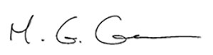

Martin Green, Chief Executive
C + K Careers Ltd



Awarded on 18th July 2023 by C + K Careers Ltd
as a Licensed Awarding Body
for the national Quality in Careers Standard

